

Automatic tiCKET ASSIGNMENT

*CAPSTONE PROJECT AIML*



nlp group 9

Supervised by

**Vaibhav Kulkarni**

INTERIM REPORT

# Project Overview:

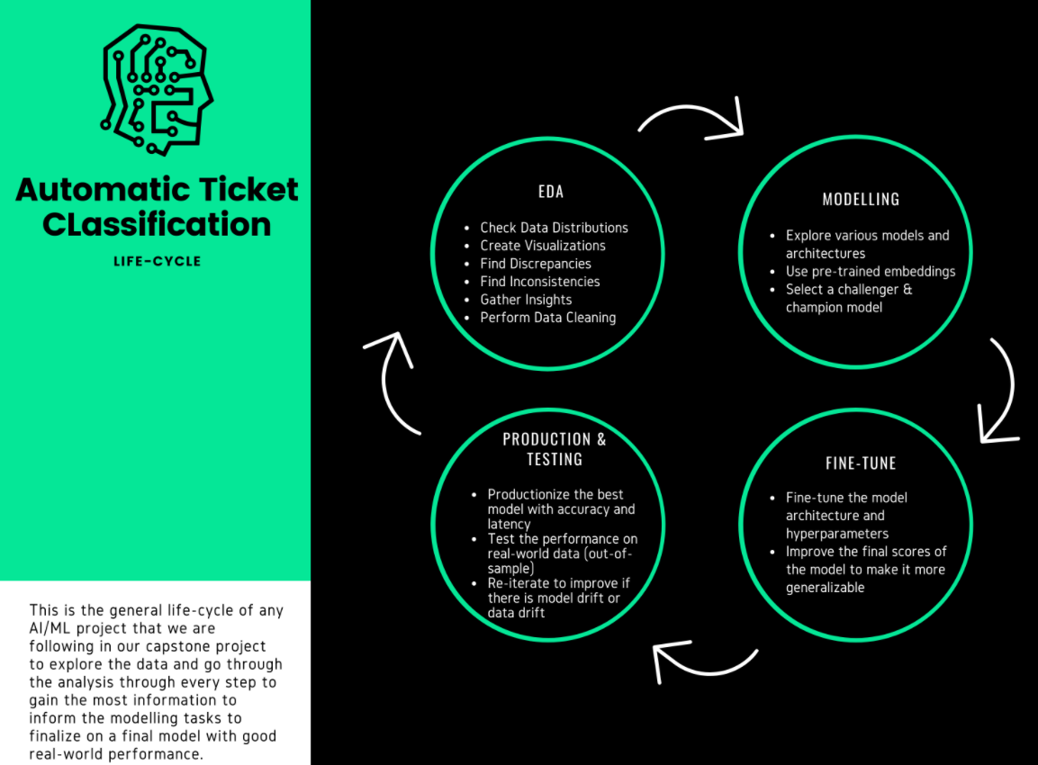

One of the key activities of any IT function is to “Keep the lights on” to ensure there is no impact to the Business operations. IT leverages the Incident Management process to achieve the above Objective. An incident is something that is an unplanned interruption to an IT service or reduction in the quality of an IT service that affects the Users and the Business. The main goal of the Incident Management process is to provide a quick fix / workarounds or solutions that resolves the interruption and restores the service to its full capacity to ensure no business impact. In most of the organizations, incidents are created by various Business and IT Users, End Users/ Vendors if they have access to ticketing systems, and from the integrated monitoring systems and tools. Assigning the incidents to the appropriate person or unit in the support team has critical importance to provide improved user satisfaction while ensuring better allocation of support resources.

## Summary of problem statement, data and findings

**Problem Statement:**

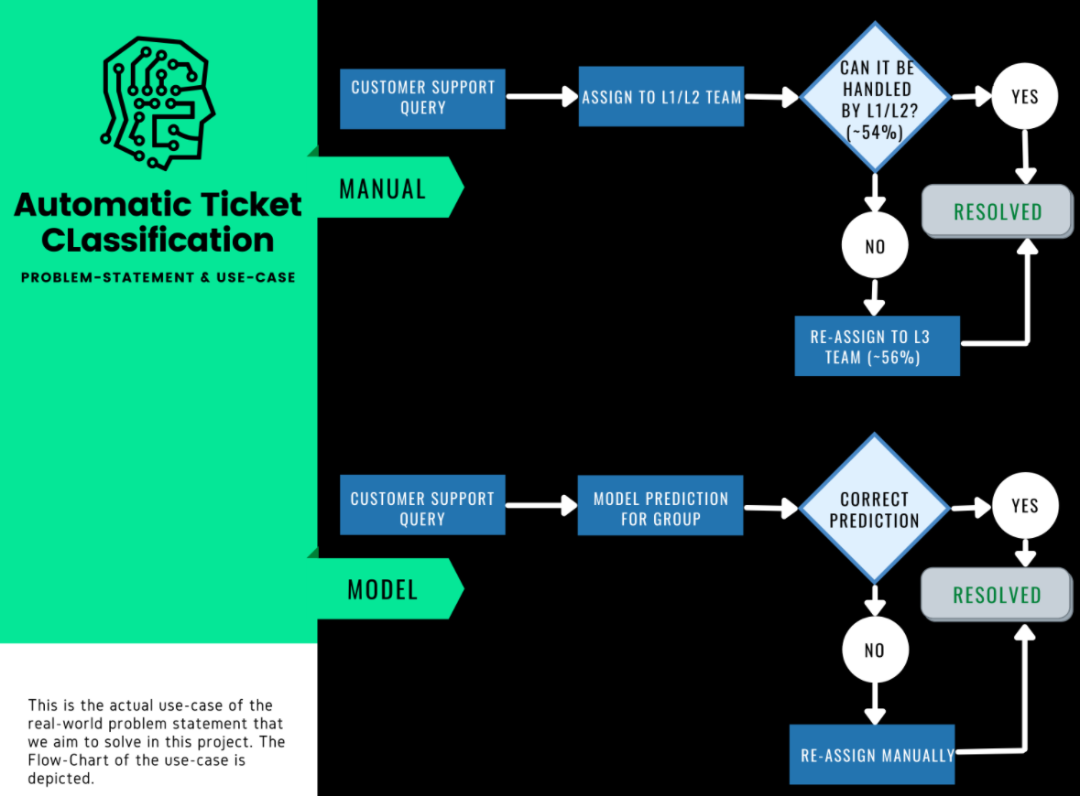

**Understanding the Business:**

In any IT industry, Incident Management plays an important role in delivering quality support to customers. An incident ticket is created by various groups of people within the organization to resolve an issue as quickly as possible based on its severity. Whenever an incident is created, it reaches the Service desk team and then it gets assigned to the respective teams to work on the incident. The Service Desk team (L1/L2) will perform basic analysis on the user's requirement, identify the issue based on given descriptions and assign it to the respective teams.

**Process:**

Currently, the incidents are created by various stakeholders (Business Users, IT Users and Monitoring Tools) within IT Service Management Tool and are assigned to Service Desk teams (L1 / L2 teams). This team will review the incidents for right ticket categorization, priorities and then carry out initial diagnosis to see if they can resolve. Around ~54% of the incidents are resolved by L1 / L2 teams. Incase L1 / L2 is unable to resolve, they will then escalate / assign the tickets to Functional teams from Applications and Infrastructure (L3 teams). Some portions of incidents are directly assigned to L3 teams by either Monitoring tools or Callers / Requestors. L3 teams will carry out detailed diagnosis and resolve the incidents. Around ~56% of incidents are resolved by Functional / L3 teams. Incase if vendor support is needed, they will reach out for their support towards incident closure. L1 / L2 needs to spend time reviewing Standard Operating Procedures (SOPs) before assigning to Functional teams (Minimum ~25-30% of incidents needs to be reviewed for SOPs before ticket assignment). 15 min is being spent for SOP review for each incident. Minimum of ~1 FTE effort needed only for incident assignment to L3 teams.

**Observations of dataset**

● Four columns – Short Description, Description, Caller and Assignment group

● 74 Assignment groups found - Target classes

● Caller names in a random fashion (may not be useful for training data)

● European non-English language also found in the data

● Email/chat format in description

● Symbols & other characters in the description

● Hyperlinks, URLS & few image data found in the description

● Blanks found either in the short description or description field

● Few descriptions same as the short description

● Few words were combined together

● Spelling mistakes and typo errors are found

# Summary of the Approach to EDA and Pre-processing: